Fall 2023

**The Saudi Pro League: The Next Big Fan-Favorite?**

The Rise of the Popularity of the Saudi Pro Football League and the Role of Cristiano Ronaldo in Bringing About this Change (1670 Words)

**Ayush Khaneja**

**ABSTRACT**

The aim of this research paper is to see the general sentiment surrounding the recent boom in player transfers to the Saudi Pro Football League as the League has attracted some big names, including Cristiano Ronaldo. The paper also aims to see the impact that Cristiano Ronaldo has had in popularizing the Saudi Pro League within the general masses. This will be achieved through content analysis of Saudi League related Reddit posts and their comments.

**1. Introduction**

Football, or Soccer, is a sport loved all over the world. It has been called “The Beautiful Game”, and people go crazy over it. It has enticed people of all ages, regions and backgrounds. Football has traditionally been seen as a sport most popular in Europe and South America, but that is not necessarily true. Football has been very popular in Africa, Oceania and Asia as well. One country where football has been booming recently is Saudi Arabia, a place with its own rich history of football.[1]

The Saudi Pro Football League has been attracting major talent from across the world, for seemingly exorbitant amounts of money.[2] There is a large shift in the transfer destinations for pro football players at the top of their game. Europe is no longer the only option to play in, and players are flocking to the Saudi Pro League, especially this season. It is a great opportunity for players to make money, and for fans to see their favorite stars take on new challenges, but not everyone is happy with this change.[3] Some football fans are of the opinion that this trend is ruining football. Players are headed to the Saudi League only to make money, and are not passionate enough about playing football. Others think that the money allocated for football transfers could have been allocated to further improve youth academies, or for other purposes entirely. With the quality of football not being the same level as Europe, people might give up their loyalty towards their favorite players as well. Speaking of players, one player seems to have had a major impact on the Saudi League getting more traction. That player is Cristiano Ronaldo, whose transfer to the Saudi League coincided with the huge influx of other players transferring into the Saudi League.

Understanding the sentiment of the fans is a useful way for to see if the Saudi League will have the support of fans, and understand why fans don’t want to follow the league so that improvements can be made accordingly. Understanding the role of Cristiano Ronaldo in popularizing the league could benefit the government and sports authorities in choosing a face for Saudi Football for the coming years. Content analysis of Reddit posts is one way understand the pulse of the public. [7], [8] That is the methodology applied to this paper.

**2. Research Questions**

The paper aims to answer two major questions surrounding this phenomenon:

1. What is the general sentiment of football fans regarding the Saudi League? Are they showing their support to the League? [4], [5]
2. Cristiano Ronaldo seems to be a major reason for the growing popularity of the Saudi League. How important is his role in popularizing the league globally? [5], [6]

Reddit, the one-stop internet destination for all things can be a handy tool to help answer these questions. The content of 50 Reddit posts about the Saudi Pro Football League, and the comments of these posts, will be analyzed to help answer the questions above.

**3. Method**

**3.1 Data**

As mentioned above, Reddit is a great place to gather data for content and sentiment analysis. The data was gathered manually. 50 posts across Reddit were collected for this purpose.

Reddit posts get a lot of comments which provide additional insight to the public’s opinions. Reddit also has flairs for categorizing the type of posts (discussion, news etc.) Reddit data is also easy to search. These reasons are why Reddit posts were chosen as the data for this analysis.

The data was gathered for the last 5 years, but the oldest posts are from about 3-3.5 years only. This is further evidence for the fact that the Saudi League has only recently started getting popular.

The posts were collected using the following combinations of Reddit searches:

* Subreddit-wide search for "Saudi League" in r/football, sorted by Relevance All-Time
* Subreddit-wide search for ""Saudi League" in r/football, sorted by Top All-Time
* Subreddit-wide search for "Saudi League" in r/soccer, sorted by Relevance All-Time
* Subreddit-wide search for ""Saudi League" in r/soccer, sorted by Top All-Time
* Reddit-wide search for ""saudi league", sorted by Relevance All-Time
* Reddit-wide search for ""saudi pro league", sorted by Relevance All-Time

**3.2 Analysis**

Once the posts were collected, a column was created to describe the post in general, what it talks about, and the general tone of the post. Then, the first research question was tackled through the creation of three custom code books. Creation of codebooks is a popular way to undertake content analysis tasks. [9], [10]

The first code book was made to see how the post is associated with the Saudi Pro League. There are news articles, threads discussing matches, general discussion, etc. How the post relates to the Saudi League is recorded in this codebook. The following categories appear in this codebook:

* **Player Highlight:** Highlights of a particular player from the league
* **Transfer Rumour:** Speculations about a player transferring to the league
* **Team Related:** Posts talking about a specific team in the league
* **Mocking the League:** Posts making fun of the league and its happenings
* **Player Related:** General posts about a particular player in the league
* **Mocking a Player:** Posts making fun of a player
* **Inter-League Comparision:** Posts that compare the Saudi League to other leagues
* **Match Result:** Posts discussing the results of a match
* **In Opposition to the League / League Practices:** Posts opposing the happenings in the league
* **Player Signing:** Posts announcing a player signing with a team in the league
* **Team Highlight:** highlights of a particular team in the league
* **Comment on the League:** Posts making a general statement about the league
* **Discussion About the League:** Posts discussing the happenings in the league
* **Supporting the League:** Posts in support of the league and what is happening in it
* **League Stats:** Posts presenting stats about the league

The second code book deals with the general sentiment of the public towards the Saudi Pro League, as understood through the posts. It contains the following categories:

* **Positive:** The post speaks in favor of the Saudi League, presents the league in a good light, or applauds the happenings in the league
* **Neutral:** The post doesn’t reflect any strong polarizing opinions on the league and presents itself in a matter-of-fact way
* **Negative:** The post is critical of the happenings in the league, is against the league, or presents the league in a bad light

The third codebook helps codify the general theme of the comments. It contains the following categories:

* **Off-Topic:** If the comments drift away from the topic of the post
* **Discussive:** Comments where a serious discussion is going on
* **Celebratory:** Comments congratulating a team/player
* **Mocking:** Comments making fun of the league, a player, or a team
* **Negatory:** Negative comments about a player, team or the league in general
* **Critical:** Adverse or disapproving comments
* **Indifferent:** Neutral comments, not having any strong sentiment or emotion
* **Serious:** Sincere comments made with careful consideration
* **Debatory:** Argumentative comments
* **Agreeing:** Comments agreeing with the contents of the post

To help understand the role of Cristiano Ronaldo in making the league grow into the daily conversation for football fans, mentions of his name in the post and comments of the post were tracked separately. Additionally, mentions of other players in the posts was also tracked to compare influences.

Relevant columns of the data were then selected for further analysis and visualization of the trends and sentiments from the gathered data.

**Results**

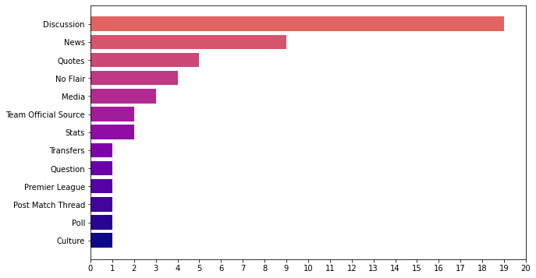

Fig. 1: Flairs of posts about the Saudi Pro League

Most of the posts (38%) were discussions about the league. Out of the 50 posts collected, only 4 (8%) were missing a flair.

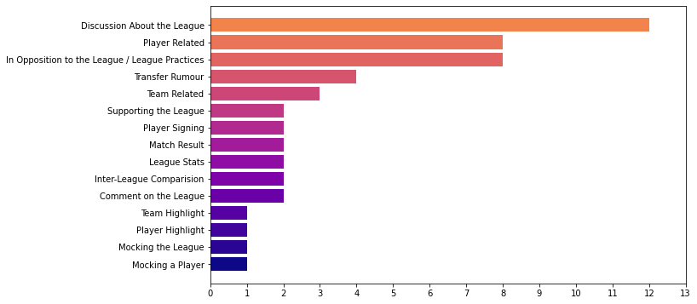

Fig. 2: Types of posts about the Saudi Pro League

Similar to the trends seen for the flairs, most posts collected were general discussions about the league (24%), and what is going on in it. A significant number of posts (16%) talked about specific players. A similar number of posts (16%) was not supportive of the league and its activities. A very small number of posts (4%) were in support of the league.

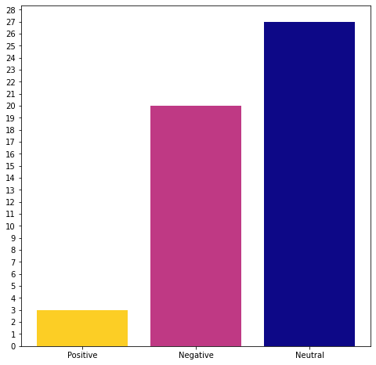

Fig. 3: General Sentiment for the Saudi League

More than half the posts (54%) had a very neutral sentiment. 20 out of the 50 posts collected (40%) spoke negatively about the league, and did not show support towards it. Just 3 posts (6%) portrayed a positive sentiment for the league.

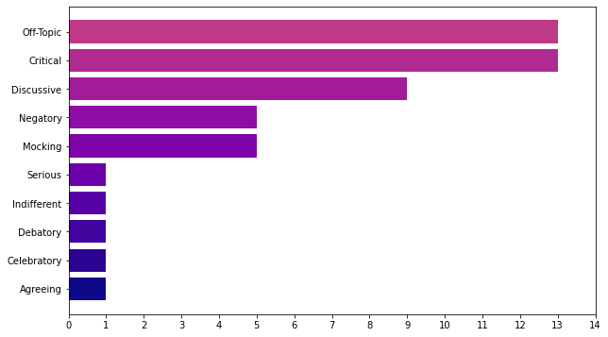

Fig. 4: Categories of comments on the posts

A similar proportion of posts (26%) had comments that went off-topic, and comments that were being critical of what was happening in and around the Saudi League. Negative and mocking comment sections together also make up a significant proportion (20%).

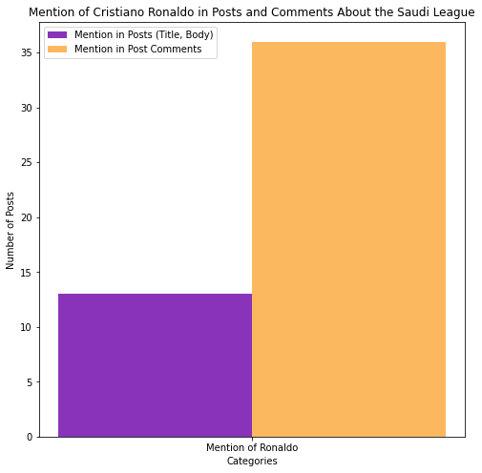

Fig: 5: Mention of Cristiano Ronaldo in Posts and Comments About the Saudi League

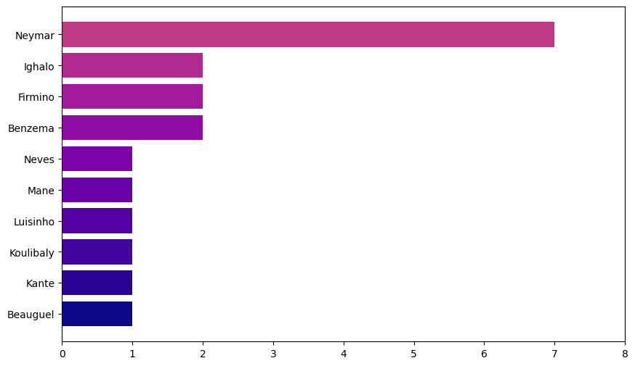

Fig. 6: Other players from the Saudi League mentioned in the Reddit posts

Ronaldo featured in 13 posts (26%) and in the comments of 35 posts (70%). Other than Ronaldo, only one player had a significant appearance in posts. That player was Neymar, who was mentioned in 7 posts (14%).

**Conclusion**

Based on the results we can conclude that football fans are not particularly excited about the Saudi League, even after the transfer of pretty big names. The sentiment is mostly neutral, but the number of negative posts and negative comments is far greater than what is being said in favor of the league. People are mostly critical about the activities around the Saudi League and are not willing to see money take over the passion and legacy of the other popular football leagues.

Cristiano Ronaldo does appear to be a significant factor in making the Saudi League popular among footballing circles, and otherwise. Even though the number of posts mentioning him directly is not that high, the number of posts whose comments talk about him is a lot.

All in all, support for the Saudi League is scarce, and the only prominent players in the league are Ronaldo, and to some extent, Neymar.

**References**

[1] <https://vocal.media/education/the-history-of-football-in-saudi-arabia>

[2] <https://www.cnbc.com/2023/09/08/pro-league-saudi-arabia-soccer-spending-ranks-second-in-world-.html>

[3] Syed, Armani (August 11, 2023). Saudi Pro League Spent Big Money on Big Stars. But the Fans Aren't a Sure Bet. <https://time.com/6304203/strongsaudi-arabia-soccer-pro-league/>

[4] Binjwaied, M., Richards, I., & O'Keeffe, L. A. (2015). The factors influencing fans’ attendance at football matches in the Kingdom of Saudi Arabia. Athens Journal of Sports, 2(2), 111-122.

[5] Ghosh, Arpan (February 10, 2023). Saudi Arabian league’s viewership increases 7 times after Cristiano Ronaldo’s move to Al Nassr: Reports. <https://firstsportz.com/saudi-arabian-leagues-viewership-increases-7-times-after-cristiano-ronaldos-move-to-al-nassr-reports/>

[6] Schreyer, D., & Singleton, C. (2023). Cristiano of Arabia: Did Ronaldo increase Saudi Pro League attendances?. Available at SSRN 4552736.

[7] Gui Jr, H. (2019). *Stock Prediction Based on Social Media Data via Sentiment Analysis: a Study on Reddit* (Master's thesis).

[8] Thapa, B. (2022). Sentiment Analysis of cybersecurity content on Twitter and Reddit. *arXiv preprint arXiv:2204.12267*.

[9] Zhang, G., Ding, Y., & Milojević, S. (2013). Citation content analysis (CCA): A framework for syntactic and semantic analysis of citation content. Journal of the American Society for Information Science and Technology, 64(7), 1490-1503.

[10] Fonteyn, M. E., Vettese, M., Lancaster, D. R., & Bauer-Wu, S. (2008). Developing a codebook to guide content analysis of expressive writing transcripts. *Applied Nursing Research*, *21*(3), 165-168.